Mathematics  Length and Height  - Fractions  - Time  - Statistics  - Position and direction  Things to practice  Multiplying and dividing by two, five and ten.  Odd and Even numbers.  Science  In science this term, we will be investigating plants. We will be learning the difference between the different stages of a growing plant, we will be designing an experiment and researching optimal plant environments for growth.  Homework  Homework will be expected in and completed on a Monday. This will then be marked and returned on the same day to give a whole week (plus weekend) to complete the following weeks. If you have any issues completing this, please contact your class teacher.  DT  We will start the summer term learning about boats, designing our own ones and then testing their floating properties. | RE  Summer 1  Who is Muslim and how do they live?  Summer 2  What makes some places sacred to believers?  PSHE  In PSHE the children will be learning about the learning process, the importance of healthy eating, physical activity and vaccination. They will also learn to names of the major internal organs. |  | Music  In Music the children will:  Listen to and learn about many different styles of music.  Enjoy dancing and learning about the songs.  Sing, move and dance.  Play the glockenspiels.  Compose and create their own sounds and melodies. | Writing  During the Summer term Year 2 class will be exploring an Information text based on ‘Trees, Leaves, Flowers, Seeds.’  We will write a story based on a book ‘The Building Boy’ by Ross Montogomery and David Litchfield.  We will also learn to write a persuasive letter and our own poem.  Reading Comprehension  The Enormous Crocodile (VIPERS)  Reading  Reading and listening to your child read every night makes a big difference to their progress in all areas of learning. The children will be reading books that correspond with their RWI book at school.  Books will be changed every 3rd day of our RWI program.  The children will continue the AR reading scheme. They will be awarded a sticker if they achieve 100% on an AR reading quiz that week. For every 25 reads – Your child is rewarded with a small prize.  The children will have an opportunity to visit our school library and choose a library book to take home on Fridays. Enjoy reading the book together with your child for a week and remember to send it back to school on Fridays.
Summer term Fal Class

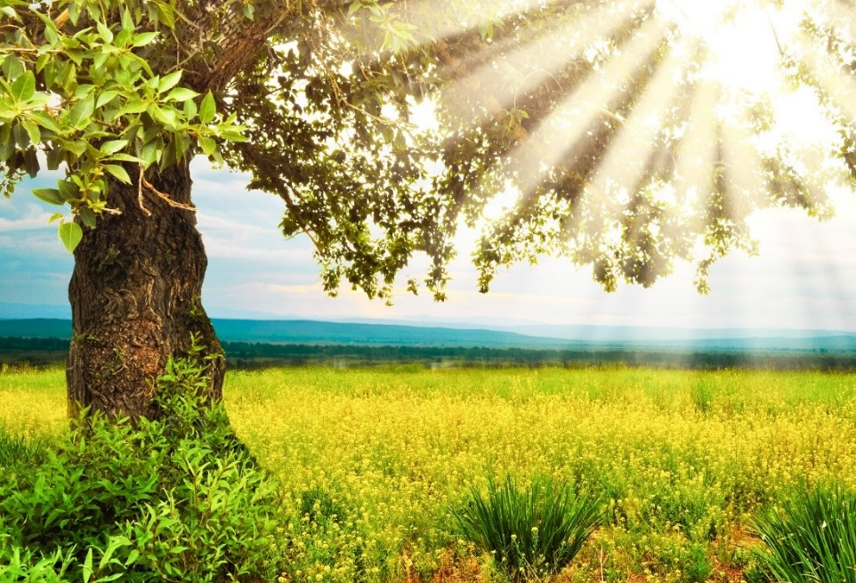
 | Geography  This term, we will be learning about hot and cold places. |  | PE  Our PE sessions will be on Wednesdays and Fridays. Please make sure your child brings in their PE kit.

