Maths  - Multiplication and division  - Money  - Fractions  - Shape  - Position and direction  Things to Practice  - Times Tables up to 12x12  - Consolidation activities at home to recap our maths learning from school. | English Reading  Reading VIPERS scheme based around the books:  The Explorer by Katherine Rundell  Who Let The Gods Out? By Maz Evans  Earthquakes and Tsunamis – Non-fiction  English Writing  We will be writing the following genres based on the following books, which are all based on the scheme ‘The Write Stuff’ by Jane Considine’:  ‘Should we feed animals at national parks? By Chris Turnham - Non-fiction  The Explorer by Katherine Rundell  The fantastic flying books of Mr Morris Lessmore by Moonbot Studios | Art and DT  Our Art and DT skills this tern include:  - DT modelling using scrap materials  - Abstract art (Drawing, collage, painting)  Science  - Properties of Materials (conductors and insulators, soluble materials, separation through filtering, evaporating or sieving)  - Changes of Materials (evaporation, irreversible/reversible changes, chemical reactions, oxidation) | Computing  Scratch Coding  We will be learning how to use code to create repetition in games and understand the outcomes from changes in code. We will then design our own games in scratch.  Music  In our music lessons we will be continuing to learn and progress on the glockenspiels and then learning and singing the song, ‘Dancing in the street’ and ‘Stop Bullying’.
Geography  In Geography this term our topic is ‘Fair Trade and economics’ which includes investigating what ‘fair trade’ means, what goods are imported/exported to different countries and why, the impact this has on the people, the trade links the UK has with other countries, to investigate if fair trade is important and how it can be improved, the effects of multinational companies on local trade, and how we can make trade fairer.  History  In history, we will be learning about the Vikings. We will investigate why they came to Britain, how the Anglo-Saxons dealt with them, and their beliefs, morals, Gods and kings. | 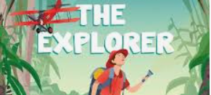 Lynher Class 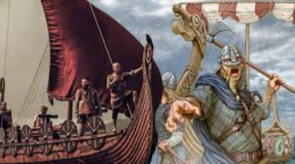  Summer Term 2024 |  | Homework / Spellings  Homework and reading records will be given out on a Monday, and we request it is returned by the following Monday. There will be a weekly spelling quiz every Monday. Reading and listening to your child read every night makes a big difference to their progress in all areas of learning and an aim of 5 ‘reads’ per week is encouraged in the reading record.  For every 10 reads – a raffle ticket goes into a jar to win a prize at the end of term. For every 25 reads – Your child is rewarded with a prize.
 | PE  Tuesdays and Thursdays for this term.  Please make sure your child brings in their PE kit.  Tuesday afternoon  Fitness with Mr Cottis.  Thursday afternoon  Striking and fielding with Go Active. | R.E  In religious education, our enquiry led learning will be focused on the key question, ‘When Jesus left what was the impact of Pentecost?’. After half term we will be investigating, ‘How and why do people in Cornwall mark significant events in community life?’.  PSHE  Following our school curriculum programme, our topic is ‘Being my best’ which includes: health, fitness and nutrition, basic first aid, making choices, dealing with growing up.

