Tuesday 4th June 2024  English -Write two sentences containing ‘which’.  e.g. I have a cat, which is black.  Maths- Using your kitchen scales, weigh some items and ingredients in your kitchen. You might need an adult to help you.  If you have bathroom scales, you can try weighing yourself!  List 5 items with their weight in grams or kilograms.  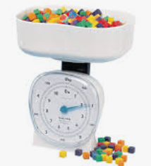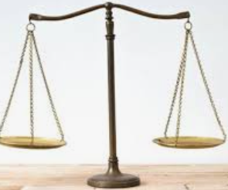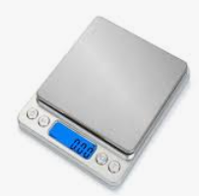 | Monday 10th June 2024  English – Write two sentences containing ‘because’.  E.g. I like playing football because its exciting.  Maths – Using a measuring jug, find the capacity of 3 different containers in your kitchen. E.g. a pan, a bowl, a cup.  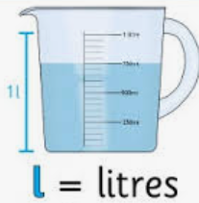
Monday 17th June 2024  English – Write a letter to an older member of your family. You might want to ask them questions like “What was it like when you were at school?”  Maths- Draw a Tally chart in your book. This could be to find out favourite food in your family. Example:  Tally Total  Pizza 9  Pasta | Monday 24th June 2024  English – Find five words ending with the  suffix -less. Challenge- Put 3 of the words into sentences.  e.g. end – endless - I wish the Summer could be endless sunshine.  Maths – Draw four clock faces:  10 minutes to 4  5 minutes to 2  20 minutes past 6  25 minutes past 9
Monday 1st July 2024  English – Write 2 sentences containing adjectives to describe the beach.  e.g. On the beach there is a vast amount of glorious yellow sand.  Maths – Draw a pictogram to show how many pieces of fruit there are in your kitchen.  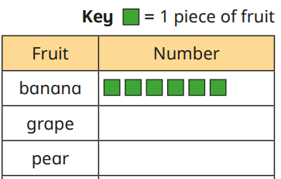 | Monday 8th July 2024  English – List ten words with -es to make it plural.  e.g. watch- watches  Maths – In a row, draw a circle a square and a triangle.  Use these words to finish these sentences:  Left middle right  The circle is ______ of the square.  The square is in the _______ of the shapes.  The triangle is ______ of the square.
Monday 15th July 2024
English- Write a short poem containing rhyming words.
Maths- Draw 3 rectangles in your book. Shade ¼ in the first shape ½ in the second and ¾ in the third.

