Maths  The children will be learning more about the 4 operations and fractions in Spring term 1 and term 2  Addition, subtraction, long and short multiplication and long and short division  Fractions…equivalent, improper, mixed  adding/subtracting/multiplying & dividing | Reading  Please read with your child as much as you can. 10/15 minutes every day would be ideal as it makes such a big difference to their progress.  Computing  Spring term 1: 3D Modelling  Spring term 2: Microbits | Art  Making monotypes  DT  Design and construct a shelter  Music  Charanga | English  Autumn 1  Writing a poem – based around the book, The Moth by Isabelle Thomas  Autumn 2  Writing a narrative: Rose Blanche by Ian McEwan  Spellings using The Spelling Book by Jane Considine  Spelling Quiz every Wednesday
PSHE  Yr 5-  Yr 6-Growing & Changing inc SRE | SPRING 2024  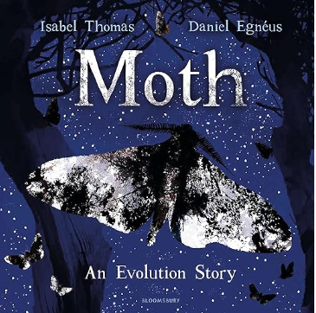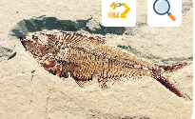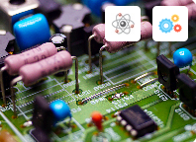
Science  Autumn 1: Evolution & Inheritance  key concepts of evolution and inheritance by building upon previous topics, including animal characteristics and fossils. The children will learn about inherited traits and apply their knowledge to various animals and plants, before being introduced to the work of Mary Anning and Charles Darwin.  Autumn 2: Electricity  associate the brightness of a lamp or the volume of a buzzer with the number and voltage of cells used in the circuit; they learn how to compare and give reasons for variations in how components function, including the brightness of bulbs, the loudness of buzzers and the on/off position of switches; and finally, they use recognised symbols when representing a simple circuit in a diagram. |  |  | R.E  Spring term 1: GOD: What does it mean if God is Holy and Loving?  Spring term 2: Why is the Torah so important to Jewish people?  Geography Autumn term 1  Russia the record-breaker  How does Russia’s geography make it a record breaker?  History Autumn term 2  WWII…  What was life like on the Home front during World War II?
 | PE  Monday and Thursdays for this term.  Please can all children remember to bring in their school PE kit.  Spring term 1: Dance  Spring term 2: Gymnastics  MfL  My family and my surroundings | Homework  Maths and spellings will be given out each week, with additional reading comprehensions and SPAG (spelling, punctuation and grammar) tasks throughout the term as part of a homework grid  Homework will be given out on a Friday and return dates provided.

