
Shortlanesend Reading Curriculum Summary
Class Novel
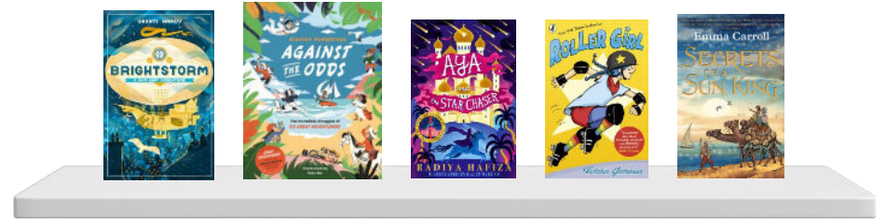
The carefully chosen, high-quality class novel will be read for 15 minutes every day separate to the reading lesson and this is the absolute last thing that should fall off the timetable. This ensures children have access to and study a text in its entirety from start to finish and build the skill of following a text through. These lessons focus on the skills of prediction and summary more than the other three as these are better applied to the entirety of a text.
There will be a daily reading lesson from 9-9.30am.
This reading curriculum will incorporate VIPERS, which is an acronym to aid the recall of the 6 reading domains as part of the UK’s reading curriculum. They are the key areas which we feel children need to know and understand in order to improve their comprehension of texts.
Vocabulary, Inference, Prediction, Explanation, Retrieval, Sequence or Summarise
The 6 domains focus on the comprehension aspect of reading and not the mechanics: decoding, fluency, prosody etc. As such, VIPERS is not a reading scheme but rather a method of ensuring that teachers ask, and pupils are familiar with, a range of questions.
Tuesday and Friday Lessons- linked to class novel
These 2 lessons a week are based on the class novel. The questions are based on the chapters they have currently read.

Tuesday, Wednesday and Thursday- linked together with a theme
These days link together with a theme. The carefully selected, age-appropriate texts should cover all genres: fiction, non-fiction, poetry, songs and picture books. The main skills covered should be inference and retrieval.

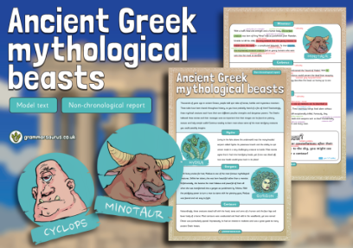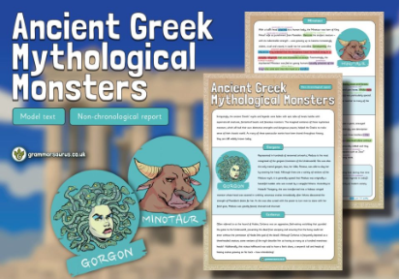

Linked Text Lesson Structure

