Helford Class Summer 2024 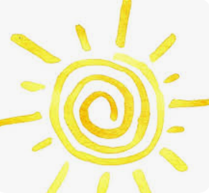
English- Reading  Over the term we will be reading a range of different fiction and non-fiction books together as part of our VIPER sessions.  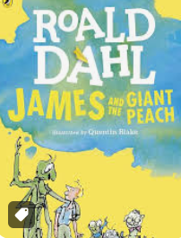 | English- Writing  This term we will be writing alternative fairy stories, letters, information texts and myths.  Our first writing unit will be based on the book, The True Story of the Three Little Pigs. 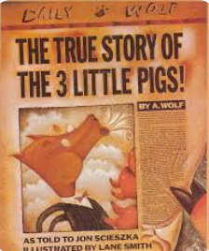 | Maths  During maths lessons we will be learning about mass and capacity, fractions, money, time, geometry and statistics. .  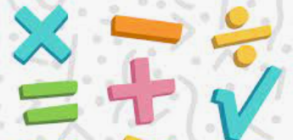 | Science  This half term we are finding out about plants.  After half term we will be investigating Forces and Magnets.  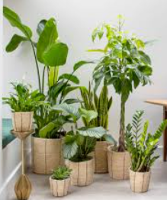
Geography  We will be learning all about islands and comparing the Scilly Isles to Greek Islands.  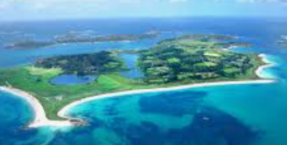 | History  After half term we will be finding out about Ancient Greece  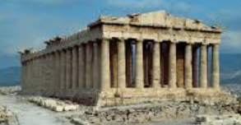 | PE  PE lessons will take place on a Wednesday.  Later in the term we will be swimming. | DT/ Art  We will be learning to design and create a mini greenhouse.  We will be continuing to improve our drawing and painting skills.
Music  We will be enjoying improvisation.  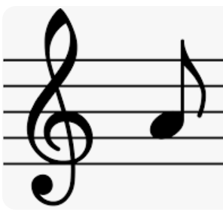 | Computing  We will be continuing to improve our typing skills and looking at animation. | RE  We will be learning about Cornish Festivals and the Gospel- What kind of world did Jesus want? | PSHE  We will be learning about being our best.  French  Transport and revising previous topics.

