Nursery & Reception

Shortlanesend School
EYFS Reading Spine
2023-24
Nursery:
Autumn 1: All about me!  Key Text: Elmer  Focus Rhymes:  If your Happy and you Know it  Heads, Sholders, Knees, and Toes  3 Little Speckled Frogs  3 Cheeky Monkeys Swinging in a tree  I’m a Little Hedgehog  Big Red Combine Harvester | Autumn 2: Why Do We Celebrate?  Key Text: Stickman  Focus Rhymes:  1 Finger 1 Thumb  1,2 Buckle My Shoe  Firework Number Rhyme  I’m a little Snow Man  Christmas Pudding  We wish you a merry Christmas  Twinkle twinkle Christmas star
Spring 1: People Who Help Us!  Key Text: Rosie’s Hat  Focus Rhymes:  Three Little Kittens  4 Tedy Bears  5 Snow Men  Miss Polly Had A Dolly  Goldilocks went to the House of the Bears | Spring 2: How Does your Garden Grow?  Key Text: The Sunflower Sword  Focus Rhymes:  I’m a Little Bean  Driving Along in a Big Green Tractor  Ba ba Black Sheep  Dingle Dangle Scarecrow  Old McDonald  How to Make the Flowers Grow Song
Summer 1: Big Adventures with Little Feet!  Key Text: The Very Hungry Caterpillar  Focus Rhymes:6  5 Little Men in a Flying Saucer  Humpty Dumpty  Ring a Roses  Jack and Jill  The Wheels of the Bus  Down at the Station | Summer 2: I Wonder What’s at the Seaside?  Key Text: The Snail and The Whale  Focus Rhymes:7  Sleeping Bunnies  One Big Hippo  Row Row Row Your Boat  I had a little Turtle  1,2,3,4,5 Once I caught a Fish Alive  A Sailor Went to Sea  The Big Ship Sails

Shortlanesend School
Recommended books for:
EYFS Nursery: Topic Linked

Autumn 1: All about me! Key Text: Elmer | Autumn 2: Why Do We Celebrate?  Key Text: Stickman
Spring 1: People Who Help Us! Key Text: Rosie’s Hat | Spring 2: How Does your Garden Grow? Key Text: The Sunflower Sword
Summer 1: Big Adventures with Little Feet! Key Text: We’re Going on a Bear Hunt | Summer 2: I Wonder What’s at the Seaside? Key Text: The Snail and the Whale

Shortlanesend School
Recommended books for:
EYFS Nursery: Repetitive Books
All books are excellent tools for encouraging language development. Predictable and repetitive children’s books are great for children with language disorders and those who have childhood apraxia of speech (CAS) or other speech-sound disorders. The repetitive nature of these books reduces the “cognitive load,” allowing the child to focus on comprehension (language) and production (articulation) of the content. Books provide new vocabulary in context, provide visuals to help aid in comprehension, and can be used to address a variety of skills depending on how they are used: receptive language, expressive language, articulation skills, and fluency.

Shortlanesend School
Recommended books for:
EYFS Nursery: Great Books to Share

Shortlanesend School
Recommended books for:
EYFS Nursery: Great Books for Maths

Reception:
Autumn 1: All About me & Autumn  Key Text: Rosies Walk  Focus Rhymes:  1. Five little apples  2. Five little ducks went swimming  3. Five currant buns  4. Five little men in a flyer saucer  5. Five cheeky monkeys  6. Five little speckled frogs  Super six guided reading books:  - Owl Babies  - We’re going on a bear hunt  - Handa’s Surprise  - The Little Red Hen  - The Colour Monster  - Beegu | Autumn 2: Festivals & Celebrations  Key Text: Handa’s Surprise  Focus Rhymes:  1. Twinkle Twinkl Little Star  2. Remember Remember the 5th of November  3. When you want to make a spell  4. The North Wind doth blow.  5. The twelve days of Christmas  6. Jingle Bells  Super six guided reading books:  - Whatever Next  - The Gruffalo  - Pink is for Boys  - The Three Little Pigs  - Lucy’s Blue Day  - Elmer
Spring 1: Fairytales  Key Text: The Three Little Pigs  Focus Rhymes:  1. Old King Cole  2. The Muffin Man  4. One Two Buckle My Shoe  5. Cobbler Cobbler  6. A cat came dancing  Super six guided reading books:  1. The Tiger who came to tea  2. Farmer Duck  3. Ada Twist Scientist  4. The Gingerbread Man  5. Susan Laughs  6. My Mum and Dad make me Laugh | Spring 2: Julia Donaldson  Key Text: What the Ladybird Heard  Focus Rhymes:  1. We are marching in our wellingtons  2. The ants go a marching  3. We’re going to the zoo  4. We are driving in the car  5. I went to the animal fair  6. Busy farmer Ben  Super six guided reading books:  1. Lost and Found  2. Room on the Broom  3. Ravi’s Roar  4. Jack and the Beanstalk  5. Sully the Seahorse  6. Mrs Armitage on Wheels
Summer 1: The World is at my Feet  Key Text: Rumble in the Jungle  Focus Rhymes:  1. Wiggly Woo  2. One man went to Mow  3. Mary Mary Quite Contrary  4. Here is the Beehive  5. Oats, Beans and Barley Grow  6. Down in the Jungle  Super six guided reading books:  1. Peace at Last  2. Giraffes can’t dance  3. The Colours of Us  4. The Princess and the Pea  5. They  6. Cops and Robbers | Summer 2: Seasides / Cornish History  Key Text: Light House Keeper’s Lunch  Focus Rhymes:  1. The Big Ship Sails  2. Bobby Shafto  3. I’m a Pirate  4. There’s a hole in the bottom of the sea.  5.A Sailor went to sea.  6. When I was one, I sucked my thumb.  Super six guided reading books:  1. On the Way Home  2. Oi Frog  3. The Proudest Blue  4. Hansel and Gretel  5. Jabari Jumps  6. Where the Wild Things are.
Autumn 1: Marvellous Me Key Text: Rosie’s Walk | Autumn 2: Festivals & Celebrations Key Text: Handa’s Surprise
Spring 1: Fairytales Key Text: Three Little Pigs | Spring 2: Julia Donaldson Key Text: What the Ladybird Heard
Summer 1: The World is at my Feet Key Text: Rumble in the Jungle | Summer 2: Seasides/ Cornish History Key Text: The Lighthouse Kee per’s Lunch
Shortlanesend School
Recommended books for:
EYFS Reception: Topic Linked

Shortlanesend School
Nursery Rhymes: A Rhyme a Week

Each week the children will enjoy learning a new rhyme in school linked to our half termly topic.
Listening and joining in with rhymes really supports children’s language development. Children benefit greatly from building a stock of rhymes through hearing them repeated again and again.
A Rhyme a Week booklet will be sent home each half term in your child’s book bag so you can enjoy these at home.
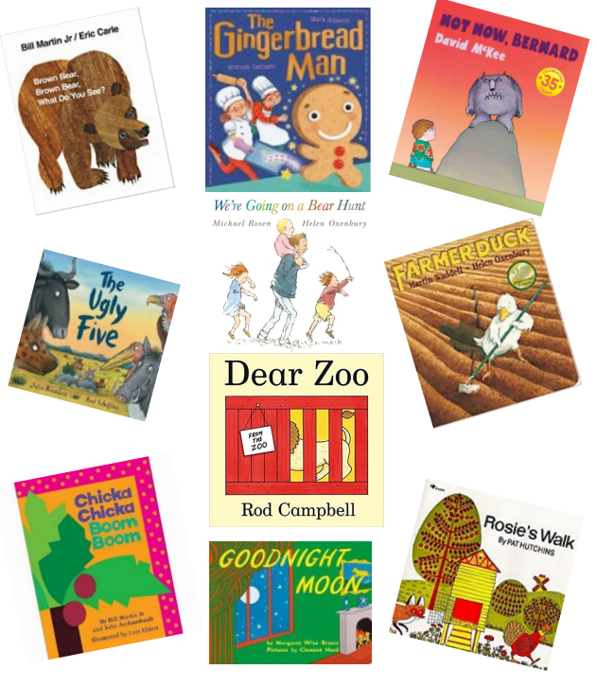
Shortlanesend School
Recommended books for:
EYFS Reception: Repetitive Books
All books are excellent tools for encouraging language development. Predictable and repetitive children’s books are great for children with language disorders and those who have childhood apraxia of speech (CAS) or other speech-sound disorders. The repetitive nature of these books reduces the “cognitive load,” allowing the child to focus on comprehension (language) and production (articulation) of the content. Books provide new vocabulary in context, provide visuals to help aid in comprehension, and can be used to address a variety of skills depending on how they are used: receptive language, expressive language, articulation skills, and fluency.

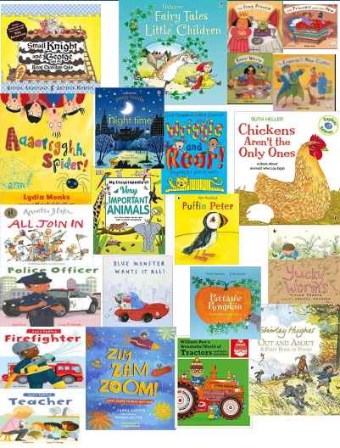
Shortlanesend School
Recommended books for:
EYFS Reception: Great Books to Share
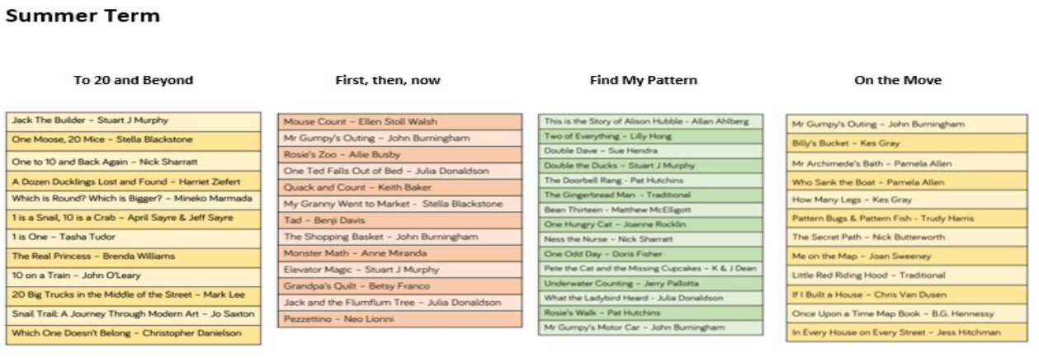
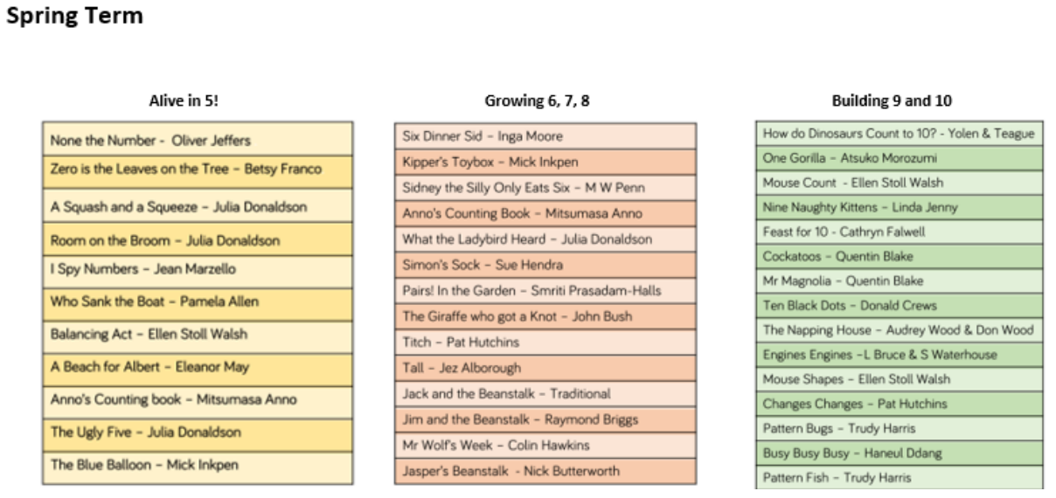
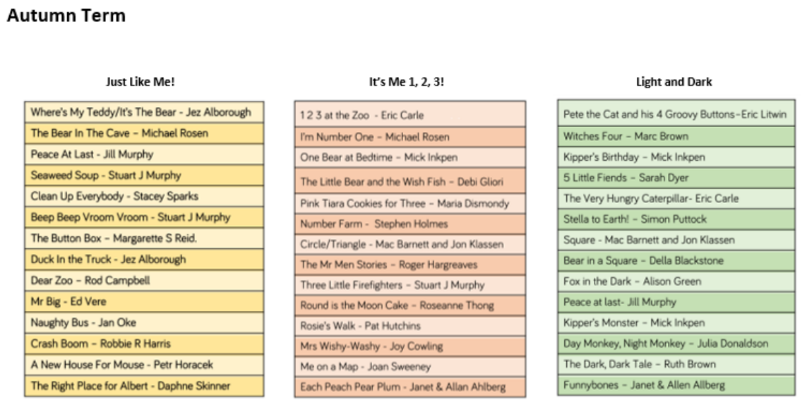
Shortlanesend School
Recommended books for:
EYFS Reception: White Rose Maths Books
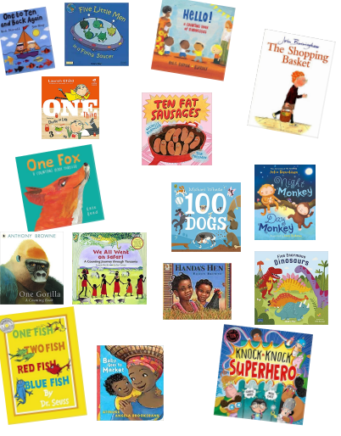
Shortlanesend School
Recommended books for:
EYFS Reception: Great Books for Maths

