Monday 15th April 2024  English - Explain in your own words what a noun is and provide some examples. Write two sentences including a noun.  Ex. I can ride a bike.  Maths- create a colourful poster to show the numbers 1-20 in words. Don’t forget to check your spelling.  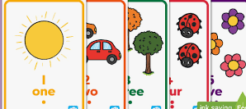 | Tuesday 7th May 2024  English - Write 4 types of sentences: a question, command, statement and an exclamation.  Ex. The cat is cute!  Maths – Practise counting up and down in 2s, 5s and 10s with an adult. Can you draw three number lines to show you’ve been practising. Like this one.  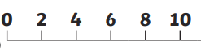
Monday 22th April 2024  English – Explain in your own words what an adjective is and provide some examples. Write two sentences including a list of adjectives.  Ex. She ate a delicious, sweet and crunchy apple.  Maths- Create a junk model to bring into school. This can be of anything you’d like. (Here are some ideas: an animal, car, train, boat, plane, tree, flower.) Can you see any shapes in the model you have made? Make a list of any 2D and 3D shapes you have noticed. | Monday 13th May 2024  English - Provide some examples of the singular and plural forms of the nouns. Make a list.  Ex. Cat – cats  Mouse- mice  Maths – Using a ruler, measure the height of 5 items in your house and complete the grid below.  Item Height (CM or M)
Monday 29th April 2024  English - Explain in your own words what a verb is and provide some examples. Write two sentences including some verbs.  Ex. They read a lot of books.  Maths - Make a list of odd and even numbers. Challenge: can you go all the way to 20? | Monday 20th May 2024  English - Write some sentences including some joining words like ‘and’, ‘but’, ‘or’, ‘because’  Ex. Do you want chocolate, or would you like some sweets?  Maths – Draw four clock faces and then add the hands to show the following times.  - 3.00  - 10.30  - 6.45  - 7.15

