Aspect | Early Years | Key stage 1 | Key stage 2
PSHE Pupils’ wider safety  - Content on common risks (roads, fire, using equipment, medicines, strangers). | Road safety, fire/fireworks, deep water, use of equipment, keeping safe in unfamiliar places.  Nursery – SCARF  - People who help me and keep me safe  - Safety Indoors and Outdoors  - What's safe to go into my body  Reception – SCARF  - What's safe to go onto my body  - Keeping Myself Safe - What's safe to go into my body (including medicines)  - Safe indoors and outdoors  - Listening to my feelings  - Keeping safe online  - People who help to keep me safe | Road safety, fire/fireworks, deep water, use of equipment, keeping safe in unfamiliar places.  Medicines and drugs.  Emergency situations.  Year 1 – SCARF  - Super sleep  - Who can help? (1)  - Good or bad touches?  - Sharing pictures  - What could Harold do?  - Harold loses Geoffrey  Year 2 – SCARF  - Harold's picnic  - How safe would you feel?  - What should Harold say?  - I don't like that!  - Fun or not?  - Should I tell? | Road safety, fire/fireworks, deep water, use of equipment, keeping safe in unfamiliar places.  Medicines and drugs.  Emergency situations.  Year 3 – SCARF  - Safe or unsafe?  - Danger or risk?  - The Risk robot  - Super Searcher  - Help or harm?  - Alcohol and cigarettes: the facts  Year 4 – SCARF  - Danger, risk or hazard?  - How dare you!  - Keeping ourselves safe  - Raisin challenge (2)  - Picture wise  - Medicines: check the label  Year 5 – SCARF  - Spot bullying  - Play, like, share  - Decision dilemmas  - Ella's diary dilemma  - Vaping: healthy or unhealthy?  - Would you risk it?  Year 6 – SCARF  - Think before you click!  - To share or not to share?  - Rat Park  - What sort of drug is...?  - Drugs: it's the law!  - Alcohol: what is normal?
PSHE Economic understanding  - Choices about money, keeping it safe, saving vs spending, risks. | Recognising money (coins, notes).  Using money in class for day-to-day activities (eg paying for fruit).  Snack time in EYFS and KS1  Nursery - SCARF  Shopping linked to the role play area  Reception - SCARF  Looking after money (1): recognising, spending, using  Looking after money (2): saving money and keeping it safe | How money is obtained (earned, borrowed, won, gifts).  Keeping money safe.  Needs vs wants.  Different jobs and how people are paid.  Year 1 - SCARF  Harold’s money  How should we look after our money?  Year 2 - SCARF  Harold Saves | Decisions about money.  Spending vs saving.  Loans and debt.  Value vs cost.  Risks (loss, theft).  Keeping track of money.  Keeping money safe.  Year 3 - SCARF  Can Harold afford it?  Earning Money  Year 4 - SCARF  Harold’s Expenses  Why pax taxes?  Year 5 - SCARF  Spending Wisely  Lend us a fiver  Year 6 - SCARF  What’s it worth?  Jobs and taxes
PSHE Technology & media  - Forms of media and their impact (reliability of online content, risks of sharing). | Learning to use technology in learning. | Finding information using technology.  Ensuring adult supervision. | Finding information using technology.  The reliability of online content.  Risks of sharing text, information and images.
RSHE Relationships  - Pupils supported to stay safe (healthy & unhealthy relationships, respect, permission, appropriate & inappropriate contact, kindness, different families).  - Content about risks (online, where to find advice, reporting concerns).  - Supporting pupils with SEND. | Nursery – SCARF  - Marvellous me!  - I'm special  - People who are special to me  Reception - SCARF  - All about me  - What makes me special  - Me and my special people  - Who can help me?  - My feelings  - My feelings (2) | Year 1 – SCARF  - Why we have classroom rules  - How are you listening?  - Thinking about feelings  - Our feelings  - Feelings and bodies  - Good friends  Year 2 - SCARF  - Our ideal classroom (1)  - How are you feeling today?  - Let's all be happy!  - Being a good friend  - Types of bullying  - Don't do that!  - Bullying or teasing? | Year 3 – SCARF  - As a rule  - Looking after our special people  - How can we solve this problem?  - Tangram team challenge (OPTIONAL)  - Friends are special  - Thunks  - Dan's dare  - My special pet (OPTIONAL)  Year 4 – SCARF  - Human machines  - Ok or not ok? (part 1)  - Ok or not ok? (part 2)  - An email from Harold!  - Different feelings  - When feelings change (OPTIONAL)  - Under pressure  Year 5 – SCARF  - Collaboration Challenge!  - Give and take  - Communication (OPTIONAL)  - How good a friend are you?  - Relationship cake recipe  - Our emotional needs  - Being assertive  Year 6 – SCARF  - Working together  - Let's negotiate (OPTIONAL)  - Solve the friendship problem  - Dan's day (OPTIONAL)  - Behave yourself  - Assertiveness skills (formerly Behave yourself - 2)  - Don't force me  - Acting appropriately
RSHE Sex education  - Giving pupils knowledge to be well prepared for changes and for safe, healthy relationships.  - Gender identity, using correct vocabulary, misconceptions corrected. | Nursery – SCARF  - Growing and changing in nature  - When I was a baby  - Girls, boys and families  Reception - SCARF  - Seasons  - Life stages - plants, animals, humans  - Life Stages: Human life stage - who will I be?  - Where do babies come from?  - Getting bigger  - Me and my body - girls and boys | Year 1 – SCARF  - Healthy me  - Then and now  - Taking care of a baby  - Who can help? (2)  - Surprises and secrets  - Keeping privates private  Year 2 - SCARF  - A helping hand  - Sam moves away  - Haven't you grown!  - My body, your body  - Respecting privacy  - Some secrets should never be kept | Year 3 – SCARF  - Relationship tree  - Body space  - None of your business!  - Secret or surprise?  - My changing body  - Basic first aid  Year 4 – SCARF  - Moving house  - My feelings are all over the place!  - All change!  - Preparing for changes at puberty (formerly Period positive/preparing for periods)  - Secret or surprise?  - Together  Year 5 – SCARF  - How are they feeling?  - Taking notice of our feelings  - Dear Ash  - Growing up and changing bodies  - Changing bodies and feelings  - Help! I'm a teenager - get me out of here!  Year 6 – SCARF  - I look great!  - Media manipulation  - Pressure online  - Helpful or unhelpful? Managing change  - Is this normal?  - Making babies
RSHE Physical health & well-being  - Healthy eating.  - Physical health/fitness.  - Oral hygiene, sleep, sun protection, dangers of tobacco drugs & alcohol.  - Basic first aid. | Nursery – SCARF  - What does my body need?  - I can keep trying  - I can do it!  Reception - SCARF  - Bouncing back when things go wrong  - Yes, I can!  - Healthy eating  - My healthy mind  - Move your body  - A good night's sleep | Year 1 – SCARF  - I can eat a rainbow  - Eat well  - Harold's wash and brush up  - Catch it! Bin it! Kill it!  - Harold learns to ride his bike  - Pass on the praise!  Year 2 - SCARF  - You can do it!  - My day  - Harold's postcard - helping us to keep clean and healthy  - Harold's bathroom  - What does my body do?  - My body needs... (OPTIONAL)  - Basic first aid | Year 3 – SCARF  - Derek cooks dinner! (healthy eating)  - Poorly Harold  - Body team work  - For or against?  - I am fantastic!  - Top talents  Year 4 – SCARF  - What makes me ME!  - Making choices  - SCARF hotel  - Harold's Seven Rs  - My school community (1)  - Basic first aid  Year 5 – SCARF  - It all adds up!  - Different skills  - My school community (2)  - Independence and responsibility  - Star qualities?  - Basic first aid, including Sepsis Awareness  Year 6 – SCARF  - This will be your life!  - Our recommendations  - What's the risk? (1)  - What's the risk? (2)  - Basic first aid, including Sepsis Awareness  - Five Ways to Wellbeing project
RSE Day
Citizenship | Right and wrong | Right and wrong  The need for rules  Different groups & communities | Democracy and its institutions  Voluntary community and pressure groups  The range of different national, regional, religious and ethnic identities in the UK.
Development of character  - Ethos of aspiration.  - High expectations to fulfil potential.  - Wider opportunities.  - Pride in the school.  - Strong self-discipline.  - Consideration, respect, good manners.  - Promotion of positive character traits and celebration of these. | Aspiration is the fourth pillar – school curriculum. In all topic-based/foundation curriculum lessons, aspirations feature on the slides and the lessons are linked to real life purposes.  Behaviour and conduct is good across the school there is high expectation for all pupils, including those who are disadvantaged or/or have special educational needs. Children speak highly of the school and are proud to be a member of it.  Pupils have access to a wide-range of wider opportunities through clubs, trips, visits and visitors to the school. These opportunities also include wider experiences from inside the Trust such as: The Outdoor Lead leading forest school and conservation project sessions.  Our school ethos promotes respect and good manners and staff acknowledge this in a positive manner.  Celebrations are in place to celebrate positive traits and success – purple certificates, celebration assembly and ‘in it to win it’. Pupils have the chance to lead in areas of the school such as Reading Ambassadors, School Council, Well-being leaders and Playtime leaders.
Wider opportunities  - To develop pupils’ interests.  - To further develop character/citizenship (meaningful voluntary work and taking on responsibilities in school and the local community).  - Is there a good take-up by disadvantaged pupils and those with SEND?  - Is there sustained participation?  - Is there a good range of lunchtime and/or after-school clubs?  - Are curricular visits designed to ensure that pupils learn what is intended from the trip? | See Trips, Visits and Experiences document -  See individual Clubs monitoring document  See local context curriculum links document -  See safeguarding in the curriculum document -
British values  - Democracy, the rule of law, individual liberty and mutual tolerance and respect.  - Are pupils taught that these values are precious and not seen across the world?  - Can pupils describe what life would be like (in an age-appropriate manner) what life would be like without one or more of these values?  - Does the school ensure that British values are not presented in a stereotypical manner with just cups of tea and Big Ben? | 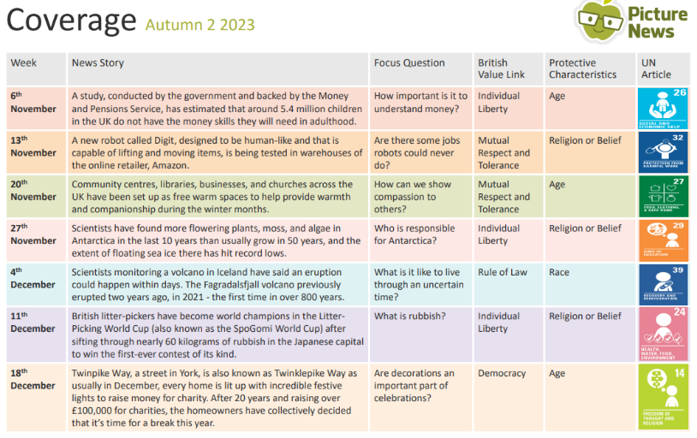  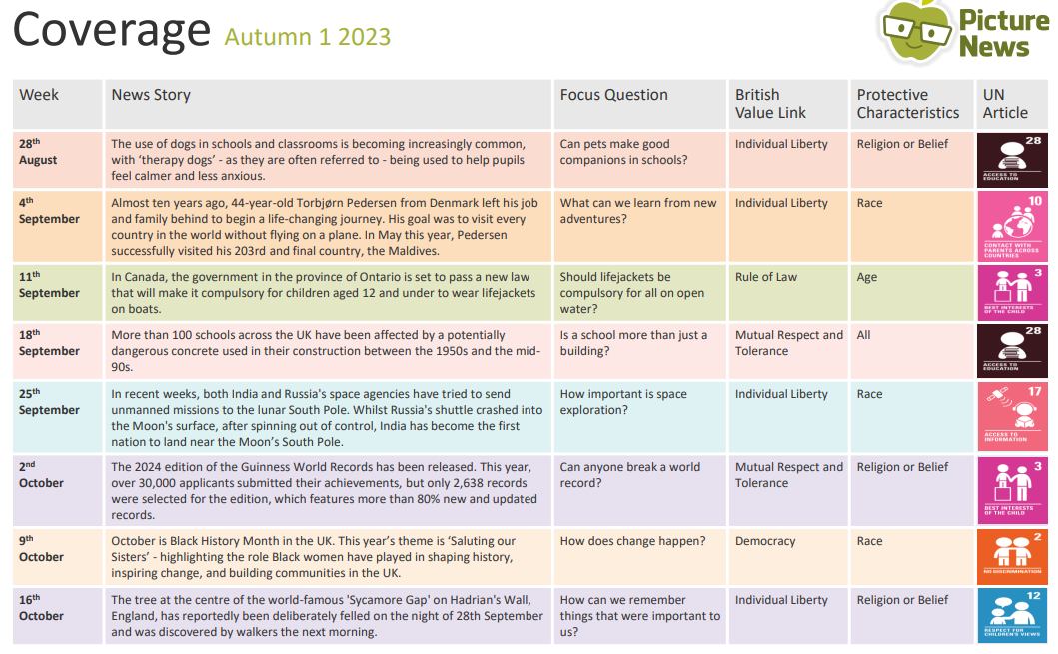
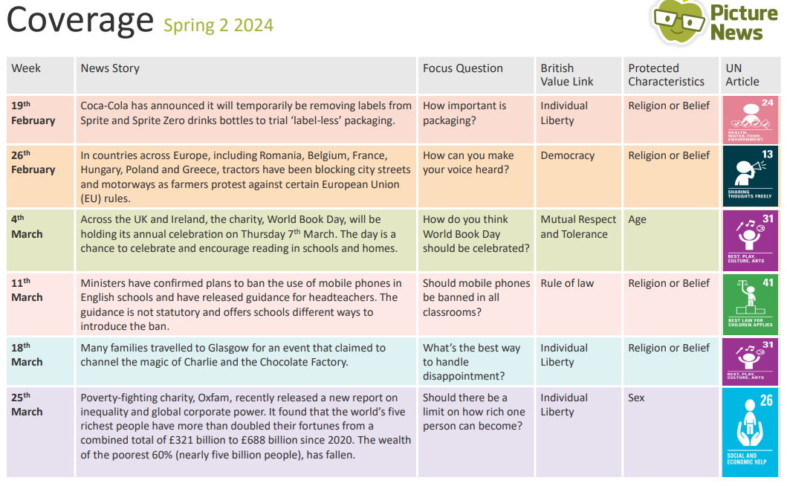
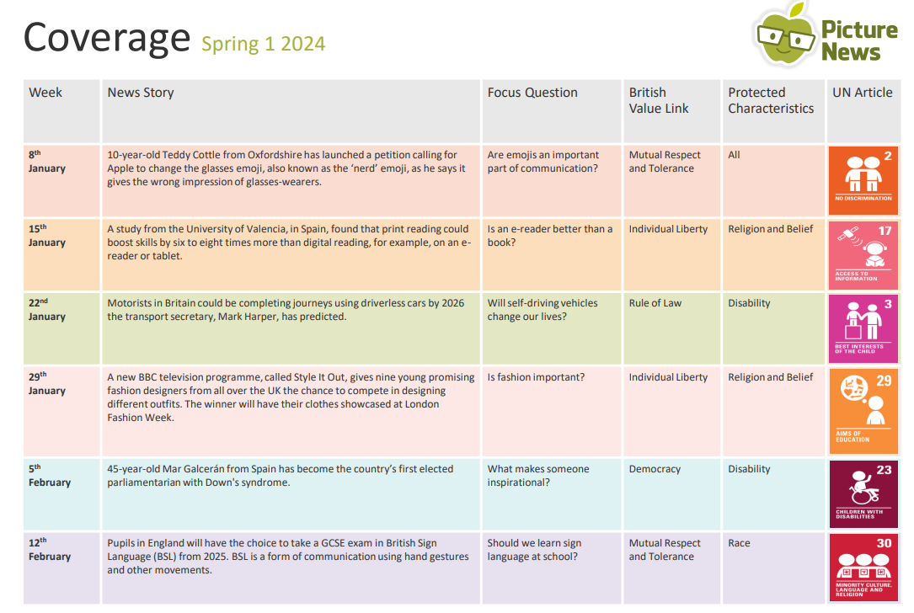
Inclusion and equality of opportunity  - No-one should be treated or thought of as less favourable because they belong to a specific group.  - Are pupils taught that not to be inclusive is to be unjust to some people? | Nursery – SCARF  - Me and my friends  - Friends and family  - Including everyone  Reception - SCARF  - I'm special, you're special  - Same and different  - Same and different families  - Same and different homes  - I am caring  - I am a friend | Year 1 – SCARF  - Same or different?  - Unkind, tease or bully?  - Harold's school rules  - It's not fair!  - Who are our special people?  - Our special people balloons  Year 2 - SCARF  - What makes us who we are?  - My special people  - How do we make others feel?  - When someone is feeling left out  - An act of kindness  - Solve the problem | Year 3 – SCARF  - Respect and challenge  - Family and friends  - My community  - Our friends and neighbours  - Let's celebrate our differences  - Zeb  Year 4 – SCARF  - Can you sort it?  - What would I do?  - The people we share our world with  - That is such a stereotype!  - Friend or acquaintance?  - Islands  Year 5 – SCARF  - Qualities of friendship  - Kind conversations  - Happy being me  - The land of the Red People  - Is it true?  - Stop, start, stereotypes  Year 6 – SCARF  - OK to be different  - We have more in common than not  - Respecting differences  - Tolerance and respect for others  - Advertising friendships!  - Boys will be boys? - challenging gender stereotypes
Spiritual, Moral, Social and Cultural development | See SMSC documents  SMSC Overview 2024 Sections merged version.docx  smsc 2022-23.pub
Effective pedagogy for PD  - Pupils revisit previous content.  - Teachers check what pupils know.  - Pupils’ misconceptions are addressed.  - Relationships are positive and respectful. | Pupils revisit previous content.  Teachers check what pupils know.  Pupils’ misconceptions are addressed.  Relationships are positive and respectful.
Effective assessment  - Teachers check pupils’ knowledge.  - Formative assessment is timely and focused.  - Pupils have secure knowledge across elements (British values, finances etc…). | Teachers check pupils’ knowledge.  Formative assessment is timely and focused.  - A range of assessment techniques are used to assess a child’s understanding. Teachers effectively use questioning within lessons and transfer knowledge across the curriculum.  Pupils have secure knowledge across elements (British values, finances etc…).  - SCARF is a comprehensive scheme which covers all areas of learning, including SRE and finance. The British Values element is furthered developed through the use of Picture News which allows children the chance to engage with and debate on a current topical theme.
Effective culture for PD  - Pupils are interested and engaged in the programme.  - There are high expectations of what pupils can learn.  - Content is supported by a package of wider opportunities. | Pupils are interested and engaged in the programme.  - BfL is good throughout lesson visits and pupil books demonstrate that they are reflective in their learning and this is applied across the curriculum. Example: pupils know that learning about resilience helps them to become better learners by enabling them to keep on trying if they make a mistake or do not know the answer.  There are high expectations of what pupils can learn.  Content is supported by a package of wider opportunities.
Effective leadership of PD  - Monitoring, evaluation and review.  - Staff have good subject knowledge.  - Strengths and weaknesses are identified.  - There is clear continuity and progression from early years to Year 6.  - The aims of the PD programme are shared with parents. | Monitoring, evaluation and review  - The school has a Personal Development lead as well as an individual leader for PSHE and Picture News.  - PSHE (SCARF) is well-implemented across the school and children can talk about their learning and how it impacts on their everyday life and choice  - Picture News is well-implemented and allows pupils to understand how our British Values relate to current news and affairs.  - Sex and Relationships Education is taught through SCARF.  Staff have good subject knowledge.  Strengths and weaknesses are identified.  - Parent Voice  - Pupil Voice  - Current demographics  There is clear continuity and progression from early years to Year 6.  - Curriculum Overview is designed using the units from SCARF, including some of the suggested optional units to ensure good coverage of topics such as economics.  The aims of the PD programme are shared with parents.  - Shared on the school website  - SRE aims shared each year  - Parent survey yearly  - Trips and visits include purposeful links to the curriculum

