

Handwriting at Shortlanesend

Daily 15 minute lesson
- Start the lesson with a hand and shoulder warm up activity.
*See handbook for examples

- Next, draw around the infinity sign to help strengthen the movement in the wrist.
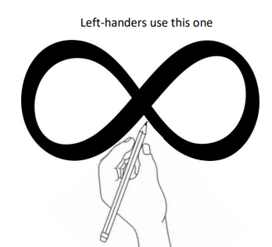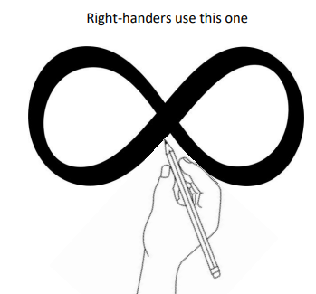

- Reception, Year 1 and 2 to complete one section of the ‘Letter formation’ book each day.

- KS2 to complete as much of the page as deemed appropriate.

Use the Teacher’s Book to find more information on:
- Key aims
- Sitting position
- Developing a good pencil grip
- Left-handed writers
- Paper position
- Correcting handwriting problems

